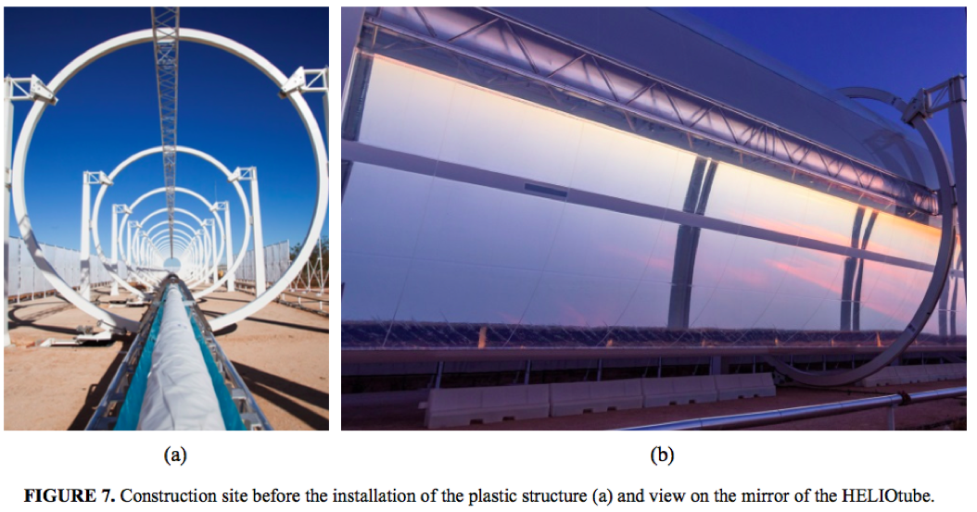

* Low cost, blow-up plastic tube solar collector

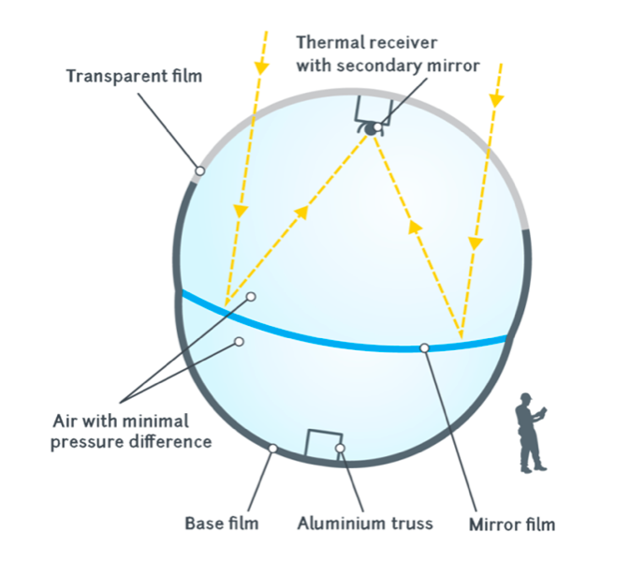

* Made of 3 plastic films
* A robust base film (made of polymer)
* A transparent film (made of acetate/polyester)
* A mirror films

<http://helioscsp.com/heliotube-plastic-tube-solar-collector-for-concentrated-solar-power/>